

Fashion Lookbook creator for an E-Commerce platform using Machine Learning

MSC in Information Systems with Computing

Naghma Khan(10514575)

**Supervisor:**

DR. SHAZIA AFZAL

Declaration of Authorship

I, Naghma Khan, a student of Dublin Business School studying Master of Information Systems with Computing. I declare that this thesis titled "FASHION LOOKBOOK CREATOR FOR AN E-COMMERCE PLATFORM USING MACHINE LEARNING “is my original work. I confirm that:

* Any part of this research has not been submitted for any qualification to any University or Educational institution.
* Where only the published work is consulted, and it is attributed.
* All sources of help have been acknowledged.

**ABSTRACT**

**The digital age evolution has resulted in E-Commerce platforms and shopping of products have become much easier as it is available online. Due to the high profits through online shopping, fashion industry has got increasingly popular. Fashion has become a trend and is growing rapidly according to the changes in trend, analysing fashion trends accurately is very important. These days Fashion recommendation systems have got high in demand. The closest implementation of such an idea is found on “Myntra” – an e-commerce portal based in India.**

**In this research work, we aim to create a fashion recommendation system called Lookbook which suggests a set of complete fashion look to the users on an E-Commerce portal. Given the user inputs based on their self-profiling such as Gender, Size, Category, Season, Complexion and Budget module will suggest the entire look. The user may then select any of these recommended looks and can modify any of the elements to suit their preferences and proceed to completion of the purchase. The system takes inputs of the modifications made by the user and by using Machine Learning algorithms the system creates recommended look. This is more optimised in terms of fashion selection and prioritization of elements. The advantage of such a system is to provide the end customers with in-trend fashionable style guides while keeping in limit of their budgetary allocations. However, there exists no major online shopping system wherein the style guides are created using the Machine Learning algorithm.**

**Acknowledgement**

**First and foremost, I would like to express my gratitude and a special thanks to my supervisor Dr. Shazia Afzal who helped me graciously throughout this research. Her valuable guidance and constant support helped me develop and complete this research.**

**I would like to thank Dr. Shahram Azizi Sazi, instructor for "Data Analytics" for teaching me several concepts of Machine Learning and encouraging me to take this topic as my research.**

**I would like to thank my family, I dedicate my research work to my parents whose constant support motivated me to pursue my master’s degree. They have always morally supported me through illness and difficulties.**

**Finally, I would like to thank my friends, my professors who have always guided me right.**

**Table of Contents**

**Chapter 1 : Introduction 6**

**1.1 Introduction: 6**

**1.2 Background and Importance of the research: 7**

**1.3 Research Aim: 9**

**1.4 Research Question: 9**

**1.5 Research Objective: 9**

**1.6 Scope and Limitations of the research: 10**

**1.7 Dissertation Road Map: 11**

**Chapter 2 : Literature Review 13**

**2.1 Literature Themes 13**

**2.1.1 Proliferation of Fashion Industry: 13**

**2.1.2 Importance of a personal styling portal on E-Commerce platform: 14**

**2.1.3 Existing Fashion Recommendation Systems: 15**

**2.1.4 Importance of Lookbook: 18**

**2.1.5 Machine Learning: 19**

**2.2 Literature Conclusion: 21**

**Chapter 3 : Research Methodology and Artefact Design 22**

**3.1 Introduction: 22**

**3.2 Research Design: 22**

**3.2.1 Research Philosophy: 22**

**3.2.2 Research Approach: 23**

**3.2.3 Research Strategy: 23**

**3.2.4 Time Horizon: 23**

**3.2.4 System Development Methodology: 24**

**3.2.4 Software Requirement specification: 25**

**3.3 Research Ethics: 26**

**3.4 System Overview: 26**

**3.5 System Design: 27**

**3.5.1 Register dashboard creation: 28**

**3.5.2 Login dashboard creation: 28**

**3.5.3 Purchase Use Case: 29**

**3.6 Modules: 30**

**Search filters required: 31**

**3.7 System Features: 33**

**3.7 Development of technologies and tools: 33**

**3.7 Database design: 33**

**3.7 Summary: 35**

**Chapter 4 : Artefact Development 36**

**4.1 Introduction: 36**

**4.2 Views: 36**

**4.2 Fashion outfit generation: 37**

**Chapter 5 : Testing and Evaluation 40**

**5.1 Testing: 40**

**5.2 Test cases: 40**

**5.1 Artefact testing: 42**

**5.1.1 Scenario 1: 42**

**5.1.2 Scenario 2: 44**

**5.1.3 Scenario 3: 44**

**5.2 Data evaluation: 45**

**Chapter 6 : Discussions 46**

**6.1 General perspectives: 46**

**6.1 Reviewing the research question: 46**

**6.2 Limitations: 47**

**Chapter 7 : Conclusion and Future Work 48**

**Appendix A: 49**

**A.1 Code Snippet. 49**

**List of Figures:**

**Figure 1: Statistics shown by “Asia Pacific Online Retail Forecast” (Chanana and Goele, 2012). 8**

**Figure 2: Working of an Online Shopping system.(Khandelwal, 2016) 9**

**Figure 3*:*Statistic data demand of Fashion market. (*Demand share of apparel market, by region worldwide 2005-2020*, 2019). 14**

**Figure 4: Most suitable AI techniques in the F&A industry.(Giri *et al.*, 2019). 15**

**Figure 5: Description of user clicks. User (a) is a young girl who likes light colour outfits and sweet styles. User (b) is a boy who is looking for lot of winter outfits. User (c) is a lady who prefers wearing formal outfits. 17**

**Figure 6: Overview of proposed framework for fashion prediction.(Lo *et al.*, 2019) 18**

**Figure 7: The Waterfall Model. 24**

**Figure 8:Overall System Workflow. 26**

**Figure 9: Activity diagram- Register page. 27**

**Figure 10: Activity diagram- Login Page. 29**

**Figure 11: Use case diagram. 29**

**Figure 12: Database Table. 34**

**Figure 13: Entity Relationship(ER) diagram. 35**

**Figure 14: The Landing page. 36**

**Figure 15: Register/Sign and Login page. 37**

**Figure 16: Reference size chart page. 37**

**Figure 17: cart_main table. 38**

**Figure 18: cart_items table. 38**

**Figure 19: learning_items table. 39**

**Figure 20: category table. 39**

**Figure 21: Positive login result. 40**

**Figure 22: Negative login result. 41**

**Figure 23: Positive buy prediction. 41**

**Figure 24: Negative buy prediction. 41**

**Figure 25: First time when user inputs the categories and clicks on search. 42**

**Figure 26: The order of outfits based on tag management as this is the first purchase. 42**

**Figure 27: The same as explained for Figure above. 43**

**Figure 28: The same as explained for Figure above. 43**

**Figure 29: The outfit purchased by the 2nd and 3rd user. 44**

**Figure 30: The list of outfits shown to the last user. 44**

**Figure 31: The list of outfits shown to the last user. 45**

**Figure 32: Graph representing the customer feedback rating. 45**

**Figure 33: Libraries used in the program. 49**

**Figure 34: Admin module creation. 49**

**Figure 35: Landing page creation. 50**

**Figure 36: Register module function. 50**

**Figure 37: Login module function. 51**

**Figure 38: Buy product page creation. 51**

**Figure 39: Buy product page creation. 52**

**Figure 40: Buy Product functionality. 52**

**Figure 41: Post Buy Product functionality. 53**

**Figure 42: Post Buy Product functionality. 53**

**Figure 43: Prediction functionality. 53**

**Figure 44: Feedback rating functionality. 54**

# 

**Chapter 1 : Introduction**

## **Introduction:**

In this digital age, with the revolution of internet the E-commerce web applications, online shopping, and the products sold on these web applications have grown rapidly.(Chavaltada, Pasupa and Hardoon, 2017). Consumers prefer shopping on E-commerce web applications due to many reasons. Such as, ease of use, flexibility to search for products with just particular keywords, availability of the product and a quick response for the keywords entered in the search option.(Jain, 2015).

There are different types of major E-Commerce Business Classifications:

Business-to-Business: **Flexfire LED**; Business-to-Consumer: **WISH**;

Business-to-Government: **Synergetics Inc** ;Consumer-to-Consumer: **eBay**; and Consumer-to-Business: **Google AdSense**.(DeMatas, 2019). As per the research done by a leading advisory firm and global research called Forrester, considering the Asia-Pacific region Indian E-Commerce market has set the CAGR of 57% from 2012-2016. The report was titled as, "Asia Pacific Online Retail Forecast". Figure 1 shows the statistics,(Chanana and Goele, 2012)

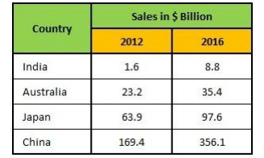

Figure 1: Statistics shown by “Asia Pacific Online Retail Forecast” (Chanana and Goele, 2012).

## **1.2 Background and Importance of the research:**

Back then, in earlier times when Barter system existed it meant that people could exchange products and services to obtain what is needed from other people. In today’s generation we still use the barter system but in a different way, money is used here as a medium to exchange goods.(Maamar, 2003).

With the internet advancements and online shopping, the products sold on E-Commerce Web applications have increased rapidly.(Ristoski *et al.*, 2018). Before deciding on something customers can look for the current trend. Even to purchase small goods such as a book or commodities, customers can access internet and complete the work by purchasing it online. There are web applications which accepts online orders and this path of carrying the business is called as E-Commerce.(Maamar, 2003) There are wide range of E-commerce businesses, Amazon is a business-consumer retail site, and websites like eBay and many others.(Maamar, 2003).

E-commerce industry is a growing industry where the opportunities given to customers to purchase products, goods or clothes is much easier.(Khandelwal, 2016). According to a study, the retail sales for e commerce in USA for the fourth quarter of 2015 was 89.1 billion dollars. And the sales across the world for E-commerce has been increasing in terms of revenue(Ristoski *et al.*, 2018). E-Commerce is helpful for the end users, as people who live in remote areas might not travel all the way to city. There are many E-commerce websites who do door delivery of products. People sitting at their homes can order anything online and get it. This will help the customer have a better shopping experience. Figure 1 clearly shows the working of an online system, where the user shops products, adds items to the cart, and completes the payment. Finally, the product is delivered home.

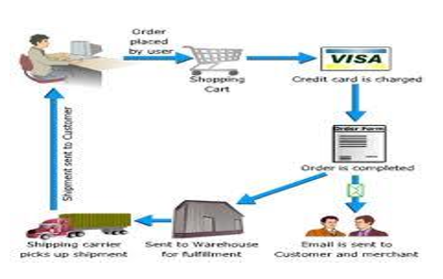

Figure 2: Working of an Online Shopping system.(Khandelwal, 2016)

The maximum sales on E-Commerce web applications according to the trends observed are from the fashion industry. Various web applications such as Myntra, Jabong, Voonik, Shein are used as platforms for the merchant to sell their products and then the customers purchase them. Fashion brands and clothing on E-Commerce web applications have bloomed from a decade, but the styling trends keep changing day to day depending upon what is new in market. The value of the fashion industry globally today is $3 trillion USD according to FashionUnited.com, which is almost 2 percent of the world's GDP(Gross Domestic Product)(Lo *et al.*, 2019).

Earlier, there was a lot of issue in bringing the actual store environment to an online portal. Due to trust issues between online platforms and customers, the development of fashion industry on an E-Commerce platform was slow. However, today due to implementation of new technologies customers have the option to evaluate the latest trends. Which has turned online shopping into a better experience and the growth of trust has increased over the period.

Based on a case study the highest grossing sales categories are apparel and accessories in Northern America, Europe and many developed Asian countries. The most important contribution of e commerce platform to fashion industry is that it has reached every corner of the world and brought it closer, figuratively and literally.

For example, if an attire is famous in one country, such as Silk Sarees which is famous in India can be purchased online across the globe. The attires worn by celebrities on red carpet events, or the garments from Paris, Milan and lot more foreign fashion is no longer foreign as it is available for every common man. (Jain, 2015). There might be times where we would want a personal styling option, or an online styling portal suggestion embedded in the E-Commerce web application. This would make it easier for the customers to buy a complete outfit. With this proposed research work we will be analysing the user inputs and based on that we will suggest the complete Fashion Look.

## **1.3 Research Aim:**

The main aim of this research is to provide a Lookbook(fashion recommendation system) for the end user. The user will input multiple categories which also includes the complete body profiling, theme of the look and the budget. The set of complete outfit looks provided will include Bottom wear, Top wear and Footwear.

## **1.4 Research Question:**

**Can Machine Learning be used to effectively address the idea of creating a Fashion trend?**

In this research question we are trying to explain that we apply Machine Learning techniques on the purchases done by the users, to suggest a set of customised outfits in the form of Lookbook.

## **1.5 Research Objective:**

So far, we have many E-Commerce web applications across the globe which includes almost all the products and goods. Every web application has different filters depending on the product the user is purchasing. For example, Amazon has filtering options for budget and selection of the categories, an Indian based start-up called StyleCracker has body profiling options and also to select the pattern of design on the clothing and Myntra has implemented a Lookbook where only the patent designers are allowed to flaunt their collection and many such Web applications have different inputs and categories.

In this research paper we create a Lookbook, we will go ahead and collaborate all features and filtering options under one platform. By creating an E-Commerce Web application where the user can register and if the user has already registered they can login. On the User Interface, the user will give inputs to the categories mentioned which will also include complete body profiling, event for the look and budget. Based on these inputs, we will provide users different outfit looks which will suit them best. And the user will also have an option to edit or remove any item which they might not like. And the purchase will be completed..

We use Machine Learning techniques on the inputs provided by customers. And provide the most accurate and best looks according to the inputs. The main goal is to provide users a Lookbook or a personal styling portal which is not available on any E-Commerce Web application till now.

## **1.6 Scope and Limitations of the research:**

The main purpose of this research is to implement machine learning to the data provided by the users in form of inputs. Based on the learning done, the best set of outfits are provided to the customers. A fashion recommendation system contains a lot of complications and features but considering the time constraints, we have not implemented a plugin.

A plugin is platform specific and cannot be embedded in a free flow manner and cannot be implemented in any of the major platforms. We will not be addressing the whole market, the web application we create is only pertaining to Fashion market. We also have an assumption, if a user selects products to buy then we are assuming that the user will purchase the product.

## **1.7 Dissertation Road Map:**

**Chapter 2 : Literature Review**

Fashion can be defined as a personal/customized mode of expression and varies from the individual to mass. Fashion industry is the most emerging industry, E-Commerce is one of the best platforms which uplifts fashion trends and reaches every corner of the world. With the evolving technology the clothing revenue has increased, and suggesting products which suits the customers can make a great impact to the market(Kalantidis, Kennedy and Li, 2013). In recent times, automatic recommendation systems for fashion has an increasing demand. These recommendation systems are beneficial to both online merchants and the customers, because it encourages the customers to buy an outfit and also helps customers get clarity about what they need(Zhan *et al.*, 2019).

As we go ahead with the Literature themes, we will discuss about how Lookbook is incorporated into an E-Commerce Web application using Machine Learning techniques/Algorithms.

## **2.1 Literature Themes:**

### **2.1.1 Proliferation of Fashion Industry:**

Fashion plays a very important role in modern society, an increasing trend is seen by the people who show interest in fashion industry. Society plays a vital role in influencing the fashion knowledge of an individual, following modern time fashion influencers creates a desire in them to adapt fashion(Kalinina, 2017). The plethora of Fashion is divided into Haute Courture(elite fashion) and casual everyday fashion rather than limiting ourselves to western fashion culture. The fashion trends depend upon the way society interprets it and judges it(Venkatasamy, 2015). Online shopping has tremendously increased on E-commerce platforms. Few websites even provide EMI options on the total bill after the purchase. Fashion industry is the largest economies which contribute 26% to Europe, 38% to Asia Pacific and 22% to the North America. Fashion industry is expected to increase the sales in Asia Pacific and Europe by 7.5% and 5.5%, according to business of Fashion(Giri *et al.*, 2019).

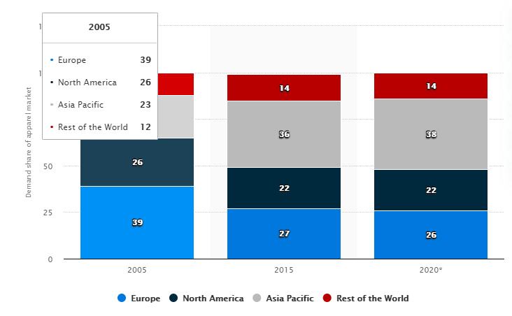

Figure 3*:*Statistic data demand of Fashion market. (*Demand share of apparel market, by region worldwide 2005-2020*, 2019).

### **2.1.2 Importance of a personal styling portal on E-Commerce platform:**

As the need for fashion recommendation has increased there are a lot of challenges faced by the fashion communities and online shopping platforms. The two main requirements for Fashion outfit recommendations are: Understanding and generating the compatible fashion outfit and Personalizing the recommendation system(Chen *et al.*, 2019). There are many ways to understand the fashion sense of a customer, asking the user to input details about them or image detection techniques or even using basic filtering.

Based on the abundant choices and the evolving styles of modern customers, outfit recommendation process has become important and has gained interest from the online retail industry. Innovation and features are the two main attributes required to generate a remarkably creative outfit, in fashion communities like Lookbook and Chictopia usually this work is done by the top fashion designers. To promote fashion outfit recommendation, an application named iFashion is created in Taobao which is the biggest online platform in China. Almost 1.5 Million content makers have been supporting Taobao as per March 31st, 2018. However, there is still a bridge between the changing market and manual labour which needs to be improved. To clear this bridge we will implement AI techniques or Machine Learning techniques to generate the fashion outfit for customers(Chen *et al.*, 2019).

For the Web application to suggest outfit recommendations, Machine Learning techniques can be implemented as mentioned earlier. However currently there are very less applications which uses these techniques in the Fashion Industry. One such example is Stylit Web application, they combine ideas of real stylists with machine learning and helps customers decide the clothing and brands that is like their style. This Web application shows us the demonstration of how fashion industry and Machine learning can be implemented together to enhance features such as Personalization(Gray *et al.*, 2015).

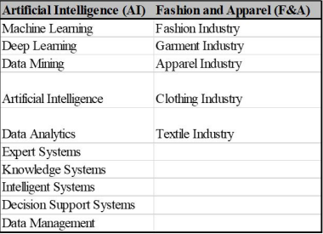

Figure 4: Most suitable AI techniques in the F&A industry.(Giri *et al.*, 2019).

### 

### **2.1.3 Existing Fashion Recommendation Systems:**

This section, outlines some of the existing techniques for automatic outfit recommendation systems,

**1)(Liu *et al.*, no date)** This is a research proposed from 1]ECE Department, National University of Singapore. 2]NLPR, Institute of Automation, Chinese Academy of Science .3]ADSC, Advanced Digital Sciences Center.

They designed a recommendation system based on two scenarios, the First scenario is suggestion of clothes based on the occasion and the most suited clothing outfit which are suggested by the users photo gallery and the Second scenario is Pairing of clothes where the user provides one clothing item(such as a white trouser) and the occasion, now the highest matching outfit pair is returned from the online shopping Web application(such as a red shirt). The clothing suggested should match with the returned clothing for the mentioned occasion, this can also be used as a plug in for any shopping Web application. SVM(Support Vector Model) framework is used to implement the recommendation system and a dataset called WOW(What-to-wear) is created with 7 multi-value clothing attributes and 10 occasion categories via Amazon Mechanic Turk.

**2)(Kalantidis, Kennedy and Li, 2013)** In this paper,the author uses image retrieval techniques such as Clustering, Segmentation and Classification to suggest the most suited outfit.

The two main scenarios here are a)Pose estimation is used the person area is segmented and cluster the image regions to detect the clothing classes in query image. b)Image retrieval techniques are used to gather similar outfits related to the one present in image from a recently annotated dataset which is quicker. More than 1 million products are suggested in the product database.

**3)(Chen *et al.*, 2019)** This research is from Alibaba Group, Beijing, China, where a POG(Personalised Outfit Generation) model is created where two requirements are looked upon one would be compatibility of the generated outfit and the other is personalization user preferences. A transformer architecture is created where POG is deployed on a platform called Dida in Alibaba to generate outfits.

A large scale dataset is created which consists of 1.01 million outfits and 0.28 billion user click actions from 3.57 million users, POG is built by a 3 step procedure, first the items are embedded, second a FOM(Fashion outfit model) is built which learns about the compatibility of the outfits and once the complete training is done the last pre-trained FOM is used to initialize POG in the Transformer Architecture. User can also add their preferences and filtering is used to collect the data from the dataset.

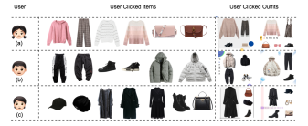

Figure 5: Description of user clicks. User (a) is a young girl who likes light colour outfits and sweet styles. User (b) is a boy who is looking for lot of winter outfits. User (c) is a lady who prefers wearing formal outfits.

**4)**(Bhuran, Mundhe and Bhave, no date)This is a web based project called “StyleCracker” which is used for personalised shopping via Internet, user can go to the Web application and log in and provide body measurements and other preferences for the outfits and the complete look is generated.

Facial expression and Image recognition system technology is used in the research work and a face recognition model is created based on the various characteristics and biometric features and the outfits are suggested. A in house stylist will help the end user to choose the best outfit.

**5)(Lo *et al.*, 2019)** This is a research proposed from National Chiao tung university and Columbia University.

This paper focuses mainly at predicting the popularity of fashion outfit by taking the learning source as social media. A deep spatial-temporal framework is developed with a dataset of 380000 images of street fashion collected from lookbook.nu. They have built an outfit recommendation for the fashion popularity trends. Feature extraction, multi modal embedding, sequential coherence discovering, and Performance comparisons are the techniques used here for prediction.

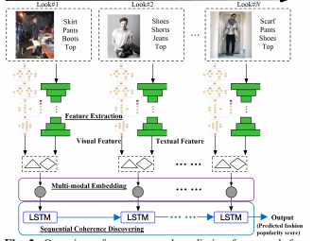

Figure 6:Overview of proposed framework for fashion prediction.(Lo *et al.*, 2019)

### **2.1.4 Importance of Lookbook:**

In earlier times, the concept of magazines were in trend especially fashion magazines where people could look for other celebrities wearing fashion outfits and purchase them from stores.

Over the time magazines concept remains the same but the process has been changed, it is more like a community. Lookbook is inspired by the street style blogs which consists of photos or outfits of ordinary people, some of which are luxury brands designed by the top designers and some of which are wearing casual outfits. Unlike other social influencer blogs or forums only images are not displayed in Lookbook, but it is also a combination of social networks and interactive forums which will allow users to post their outfit images. It is a community where all the users are encouraged to post the content generated by users and they can also communicate with other members on this online space where their fashion sense and suggestions can be showcased(‘Sense of style: Constructing Identity and managing impressions on Lookbook.NU’, 2016).

In this research paper, Lookbook is being created based on users preferences and the inputs. The complete set of looks are created using Machine Learning techniques.

Internet has become accessible to most corners of the world today, we can get answers for any query through internet. So why not we can use it to get an appropriate styling suggestion on one click. Also, we can get some options to select new outfits from a set of different outfits provided, this is much easier than physically going out and shopping. The styles can be chosen on our own ease and can be ordered online, we can choose the budget, preferences and other inputs while purchasing the item(Bhuran, Mundhe and Bhave, 2018). Lookbook is important because in today’s generation most of the Web applications use filtering option to sort the outfits, and the user must go to different categories(For example, first select women, then tops and then trousers and then shoes) and select the items. There is no approach where all the categories are present parallelly and the user inputs will be taken, and then the outfits are displayed hence the Lookbook can be helpful in this case(Hsiao and Grauman, 2018).

Right now, we do have different kinds online Lookbook portals to buy the outfits. But all of them are top branded designer outfits which common people might not be able to afford. With this research we will embed E-Commerce platform with the Lookbook, and it will aid in buying outfits at any time.

Some of the techniques that is used in this research paper, will be discussed below.

### **2.1.5 Machine Learning:**

Machine Learning is appearing almost everywhere in the industry these days, every organization and sector is scrambling to combine this language into their functions. It is defined as, the technique of Artificial Intelligence and the science of teaching machines how to learn without being programmed explicitly(‘What is Machine Learning? Understanding Machine Learning and its Types’, no date). The capability of AI systems to obtain self-knowledge by extracting the patterns from the raw data provided is Machine Learning(Cote, 2018). There is a difference of performance between Machines and Humans, where humans devote all their time to learn skills and perform a task, but machines perform just the given task correctly. This generation computers are very efficient however as time goes they cannot self-improve themselves, however using Machine Learning approaches a computer can continuously learn and improve from the data sets provided(Stefan and Nicklas, 2017). Machine Learning is preferable because it is easy to implement and provides better performance and produces a reusable software(Cote, 2018). Many applications such as email-spam detection, customer purchase patterns use Machine Learning. Different types of Algorithms and Learnings have been developed with different objectives and advantages to extract the patterns(Stefan and Nicklas, 2017).

There are 2 types of Learnings under Machine Learning considering the initial training set,

1)Supervised- In this method the system is provided with a pre-defined dataset, or defined items with categories and then the classification model is built depending upon these categories. For a new item to be classified, this model will first predict the category and then place the item automatically in it.

2)Unsupervised- In this method the data provided is unlabelled, the system has to detect the data patterns within the data and do the categorizing itself, and there is no learning involved in between the datasets(Stefan and Nicklas, 2017).

There are different kinds of algorithms under Machine Learning and the one we use in our research work is Priority Matrix. This is a matrix which is used by most of the recommendation systems where the rows and columns are assigned to the database. Initially the priority is 0, however as the purchase keeps happening. The priority of the purchase will keep increasing. And next time when the user shops for same items, the table will be looked upon. And if the purchased categories match, then the highest priority outfits will be shown first. Major platforms such as Amazon, Myntra and Flipkart had these systems working initially. But there was no recommendation system implemented based on this technique. Priority matrix does the learning part and displays the results(*4. Ranking: Priority Inbox - Machine Learning for Hackers [Book]*, no date).

## **2.2 Literature Conclusion:**

Currently there are a lot of fashion recommendation models in the market which are developed based on different AI and Machine learning techniques, recommendation of outfits is a process which keeps improving day by day so there is no decision we reach on because there is always scope for better techniques and better recommendations.

From the above discussed literature themes we can say that, some recommendation systems make use of street images this can cause confusion between the users that which look they want to try because some outfits might look good on some people but it is not necessary that the same outfit might look good on you, additionally the images would be taken with a background and there are a lot more characteristics involved which makes a picture look good. In one of the papers, user photos are taken from the gallery to suggest outfit which is a security concern and images are taken from online Web application which might cause consent issues. And there are issues with categorizing the data into similar profile groups in the dataset there is a cold-start problem which needs to be solved. Generalizing the recommendation systems created, most of them are complex in terms of usability and understandability for a user to access it and purchase the outfit.

In this proposed research, we are developing a recommendation system where the user does not have to depend on any external inputs such as images or files, the user has to go to the Web application enter the details including the budget and choose the outfit based on their own preferences, we will solve the dataset issues by categorizing the items added newly in the similar groups. The UI created for the Web application is user friendly.

**Chapter 3 : Research Methodology and Artefact Design**

## **3.1 Introduction:**

The objective of this research is to take the inputs from the user, apply Machine Learning techniques and create sets of complete looks as per the preferences suggested by the user. This chapter provides details about the research, where we are learning more about the research methods and strategies that is applied to the research as we have discussed before.

## **3.2 Research Design:**

In this section, we discuss about the methods used for collecting qualitative or quantitative data and the evaluation of the prototype is done from the useful information extracted from the data. There are three subsections for this section, Research Philosophy, Research Approach and Research Strategy.

### **3.2.1 Research Philosophy:**

The first layer of the Onion ring is Research Philosophy. Research philosophy is a certain way of building knowledge that describes philosophical paradigm. The understanding and developing of knowledge depends on basic assumptions about our idea of the world which depends on the basic idea of our research(Holden and Lynch, 2004). The philosophical approach will help the researcher decide the approach that should be used and why it should be used. In our research work we are using Interpretivism s the approach(Saunders, Lewis and Thornhill, 2009).

Interpretivism involves the researchers to understand the study elements, thus this approach integrates study of human interest. According to this approach, it is important for us as a social actor to appreciate differences between people. This approach is a combination of scientific evidences and psychological emotions. In our research keeping these scientific evidences in mind, we are trying to understand the needs and preferences of the users.

### **3.2.2 Research Approach:**

This section is the second layer in the Onion ring, which is divided in two strategies first is Inductive and the second is Deductive Approach. If the research is data driven, there is a theoretical explanation derived from the data which is first collected and analysed then we will adopt Inductive Approach.

In this approach, the data provided is collected and the patterns are identified and then the relationships involved between the data are recognized, all these factors constitutes to develop a theory but there are some existing theories which needs to be used to formulate our research and there are many more aspects of this research process we wish to explore further and there are possibilities that the efficiency will build more.(Saunders, Lewis and Thornhill, 2009). In our research we collect the data in the form of the user’s inputs and then analyse it with the existing data we have and apply learnings to the data and build the theory.

### **3.2.3 Research Strategy:**

We are using Qualitative research in our proposed work, because we are trying to access the need of people by understanding their preferences and we try to implement something in nature which is abstract. The result is totally based on the users thinking and their inputs, we keep getting data depending on different trends and in small fragments. As we get the data we implement and give the output.

The third layer in the Onion ring is the Research Strategy, the strategy we use here is Qualitative research. This provides in depth behaviour of the data we are using, it is an exploratory research which is used to obtain the understanding of motivations, emotions, opinions and reasons to get the insights of the data(Saunders, Lewis and Thornhill, 2009).

### 

### **3.2.4 Time Horizon:**

The period in which the research is carried out is known as the Time Horizon. In few cases, the researcher would want to study or understand people or phenomena at different times to answer the research question. For an example, the researcher would want to study the behaviour of students before and after change of a lecturer to know the changes that has occurred with the students(‘Time horizon: cross-sectional versus longitudinal studies’, 2016).

Because we are gathering the data at two separate points in time, this study is not cross sectional instead it is carried across a period longitudinally. This kind of study where the data is collected at more than two points to answer the research question, is called Longitudinal. In our research we are collecting the data first and processing it and giving another data as a result, hence we use this Time Horizon.

### **3.2.4 System Development Methodology:**

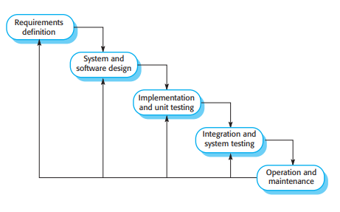

Figure 7: The Waterfall Model.

This model was introduced first by Dr. Winston W.Royce in 1970, this is a software development lifecycle model(SDLC) where the software development process has been shown in several stages. It is called as Waterfall because of the cascade from one phase to another, this model is an example of a process where we have the plan, and we schedule the process steps before we start the software building.

There are 5 stages in the waterfall model:

1)Requirements analysis and definition: This is the initial phase, where the system's potential requirements, ideas, rules and objectives are created with reference to the system user. These details will serve as a base for the further plan and will give a clear idea about what the application should do.

2)System and software design: During this second stage, a complete architecture system will be established. Hardware and Software system requirements are allocated based on the system design process. This stage will describe the relationship between the software system and design.

3)Implementation and Unit testing: This section broadly covers the technical requirements such as data layers, programming language and many more. The design is considered to be a set of programs. Unit testing is done at this stage to check if every unit is meeting the condition or the specification mentioned by the system user.

4)Integration and System Testing: At this stage to ensure that the requirements have been completed, the set of programs or program units considered in the last section are tested as a complete system. And then the system will be delivered to the system user, after the testing has been completed.

5)Operation and maintenance: Finally, the application is ready to be deployed to a live environment. This is the longest phase of the lifecycle where the installation and maintenance of the system is done, errors that were not encountered earlier in the life cycle will be corrected. The enhancement and implementation of the system units as new services are discovered(Sommerville, 2016).

In this model the next phase should not start until the previous phase has been completed this is of great help for hardware development where the manufacturing costs are high, but these phases share information with each other and overlap for software development. In our research work we use this approach because, we have clear objectives of what should be done at the initial phase, we know the technologies we are using and the form of input and output hence the system is less prone to errors. We do not have to rearrange the data and the functionalities as we would have the definitive objectives, if we had any high level project where the cost would be very high then using this approach would be time consuming in this case we could use Agile methodology. Since we have definite inputs and objectives we can use this model.

### **3.2.4 Software Requirement specification:**

To give a brief detail about the specifications of the project and entire description, we need Software requirement specification. The reason to know these specifications is to get clarity during the development phase. This research requires a web-based software, which should enrich the experience of the user and layout of the Web application must be responsive. Login and register option will be available for the users to access the web page. User integrity is ensured this way.

## **3.3 Research Ethics:**

The research ethics is concerned about following the code of conduct with respect to the data of the users. This research strives to avoid any kind of bias in data representation, data analysis, experimental design or any other aspects of this research. Data collected from all the sources is cited and referenced as per Harvard referencing style to maintain data integrity and to avoid any data misrepresentation. To ensure the confidentiality the data collected from the online portal about user’s personal details is being stored securely in the database to avoid any un-authorized access to the personal data. And the data will not be shared to any third party without the consent of the user. All the related research papers were selected from the genuine resources, authors and well-known newspaper articles. This research satisfies ethical guidelines laid down by Dublin business school research ethics checklist (Saunders, Lewis and Thornhill, 2009).

## **3.4 System Overview:**

As the idea is to develop a Lookbook which could help the users to get a complete look of their outfit based on their requirements, to prove this possibility we have created an E-Commerce web application.

First the user will enter the landing page of the Web application and if the user has visited the Web application first time then they will have to register if not then they can log in directly using their credentials.

For the look book to work, login is mandatory. Once login is successful, self-profiling based on the search parameters are completed. The system compares the filter values and maps it to the priority matrix used for prediction. The items with highest priority rating mapped under the filter results are then listed completing the look book. The user may then change individual items till satisfied and check all the items they want to purchase. This will automatically go to the cart. Once the addition is complete the system assumes the user will buy the items and after the user clicks on the affirmation of purchase, the new learning coefficients are updated in the priority matrix. The system then asks for feedback on the quality of prediction results.

Figure 8:Overall System Workflow.

## **3.5 System Design:**

We have implemented a simple overall model with basic features considering the working of and Lookbook time constraints we have. There are 3 major workflows in the system design, all of them are explained in detail below.

### **3.5.1 Register dashboard creation:**

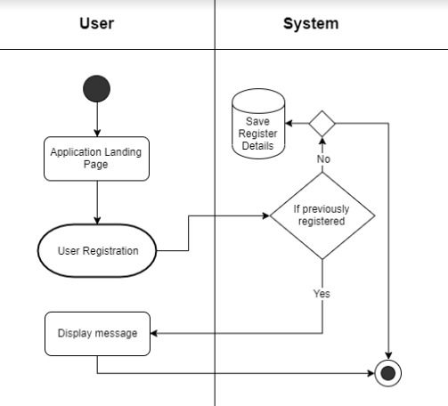

Figure 9: Activity diagram- Register page.

The diagram has been divided in two phases User and System(Back End). User will enter the landing page, they will have to click on an option called Register/Sign in the Web application. The user will try logging in, the system will check the database. If the user has been registered previously, then a message will be displayed. If not registered then the user will have to fill the Register form and the details of the user will be saved in the database.

### **3.5.2 Login dashboard creation:**

As shown in Figure 9, this is an activity diagram for login dashboard. We have created a swim lane activity diagram involving three actors User, System and Admin. The first page of the web portal would be a landing page. There are 2 possibilities here, either the session was active as an admin/user or the session had expired. As the customer enters the Landing page, the system will check the condition if the session was active as an admin. If he/she has succeeded to login they will be guided to the Admin dashboard. If the condition fails then the system will redirect the customer to the buy product page. Going back to initial condition, if the session has expired. Then the customer will be guided to the Login page where they can enter credentials to log in, the back end will check if the user is admin. The condition explained earlier will continue and the system will redirect to buy products dashboard, if the customer is a normal user and not an Admin. If the credentials are admin then the condition repeats. If the user does not get authenticated at the Login page, then the system will ask to enter the credentials again.

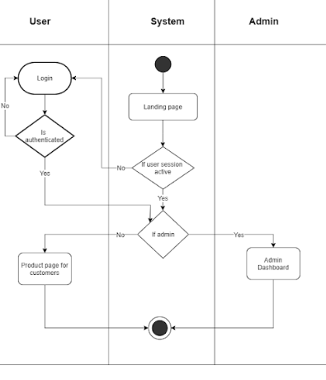

Figure 10: Activity diagram- Login Page.

### **3.5.3 Purchase Use Case:**

The basic purpose of a use case is to cover the dynamic working of the system. Both external and internal requirements of the system will be gathered, these are the design requirements. Use cases are designed, and the Actors will be prepared when a system needs to be analysed. Actor can play a role of external influencer, internal application or a human.

In the below mentioned use case diagram, there are 2 actors involved Customer and Admin. The roles played by the customer are to create account if not registered, if registered then to log in. Filter products, on the portal the user will have to input their preferences and specify the product they want to buy. The next will be to buy the product by selecting the products to be shopped and the last role would be to provide a rating based on their shopping experience about the fashion recommendation system.

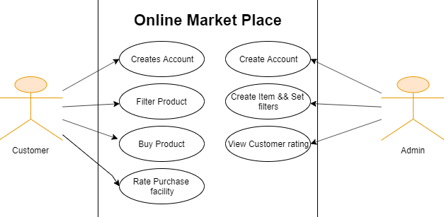

Figure 11: Use case diagram.

## **3.6 Modules:**

In this proposed research, the researcher makes a structure of the framework to improve the information, arranging of data and operational conduct. The model is created with all the basic establishments for the structure of the product and the reason of building the product.

The complete activities of our module can be divided in two main sections:

**1.Admin:** The Admin role is entrusted with the Listing,Monitoring and Managing the products along with viewing the overall feedback for the prediction portal created. The brief details about the functionalities carried by admin are,

1) Adding products: Once logged in to the Web application as admin, the main function of the admin is to add different products.

The basic conditions under which the products should be added will be known to admin. In specific to this research, can add product name, gender, season, event, rate, colour and the image. Every category that the product belongs to should be selected

2)Add Category: Admin can add the details of the clothing. Topwear, Bottomwear and Footwear. We can further add one more category called Accessories if required.

3)Add Event: The outfits given to the customer are based on a event selected by them. For ex, currently we have events such as festive, casual, sportswear etc. Admin can add any other event or occasion if required.

4)Add Size: Admin can add an extra size if required. This is an alternative to the measurement section.

5)Add Season: In the module, we have added 4 seasons which are known worldwide. The admin will have the permission to add or remove any of the seasons.

6)Add Budget: According to the products added we have also added the budget. If Admin wants to add a product which is out of the budget range, then the budget section could be changed by Admin.

2.User: It is mandatory for the user to login to utilize the functionality of the application. The mandatory requirement to login ensures better learning for the system as it avoids unwanted searches and false confirmations. The outfit generated for the user depends on their input in the search filters. The user will have to give a star feedback rating based on the shopping experience and the outfit generation. The Search parameters are dynamic, and they are default values that may be changed later.

## 

## **Search filters required:**

The search filters required for the portal along with default options are (please note that the search parameters may be dynamically managed).

1. Gender

* Male
* Female

1. Size

* Small(S)
* Medium(M)
* Large(L)
* XL

1. Category

* Top wear
* Bottom wear
* Footwear

1. Season

* Summer
* Spring
* Autumn
* Winter

1. Event

* Festive
* Party
* Sports
* Formals
* Travel
* Casual

1. Budget

* 20-99
* 100 - 300
* 300 – 500
* 500 – 700
* 700 – 1000
* >1000

## **3.7 System Features:**

This research work includes the following features:

1. Base level ecommerce application – the application has basic listing and cart features. It does not include an extensive cart management operation or payment completion or confirmation.  
2. A static content page for reference size chart

3. Self-profiling based on 6 filter coefficients

4. Predictive look book creator.

5. Admin page having dynamic control on listing, size addition, category addition, event, and budget etc.

6. A-star rating feedback to observe the efficiency of prediction in user perspective.

7. 2 bar graphs will be created based on the feedback provided by the user.

## **3.7 Development of technologies and tools:**

3.7.1 Technologies:

* Core programming language: Python 3.7
* Python platform: Flask
* Database: MySQL

3.7.2 Development Environment:

* Microsoft Visual Studio Community Edition 2019
* XAMPP v 3.2.4

## **3.7 Database design:**

In Database design, all the stored procedures and tables were designed in the first phase. The researcher follows the first approach database for the design. The diagram has been drawn based on the inner relationships between entities Database diagram. Database designing process consists of various steps such as:

1)Finding the main purpose of the database.

2)Gather the required information.

3)Partition the information in the required tables.

4)Divide the information into columns.

5)Identify the primary keys for every table.

6)Organize the relationships of the tables.

7)The normalization rules are applied at the end. The database table is shown in the below Figures 12 and 13.

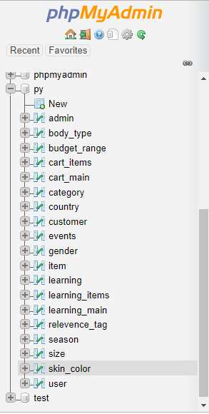

Figure 12: Database Table.

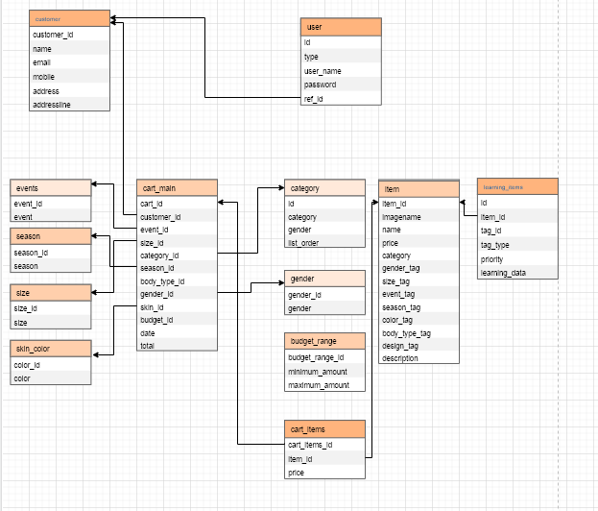

Figure 13: Entity Relationship(ER) diagram.

## **3.7 Summary:**

In this section, the researcher has described the design of the artefact in detail. The Lookbook features and the Web application details are discussed and included in the context.

**Chapter 4 : Artefact Development**

## **4.1 Introduction:**

In this section, we will discuss in brief how the artefact has been developed. The different modules of the Web application and the techniques used to generate the fashion outfit are discussed thoroughly.

## **4.2 Views:**

**The landing page**

The landing page is the main screen of the Web application. This page contains a menu bar which has options such as Register/Sign, Reference size chart, Buy and Logout. All the pages can be accessed from the landing page, which means the links to other screens should be mentioned in the menu bar.

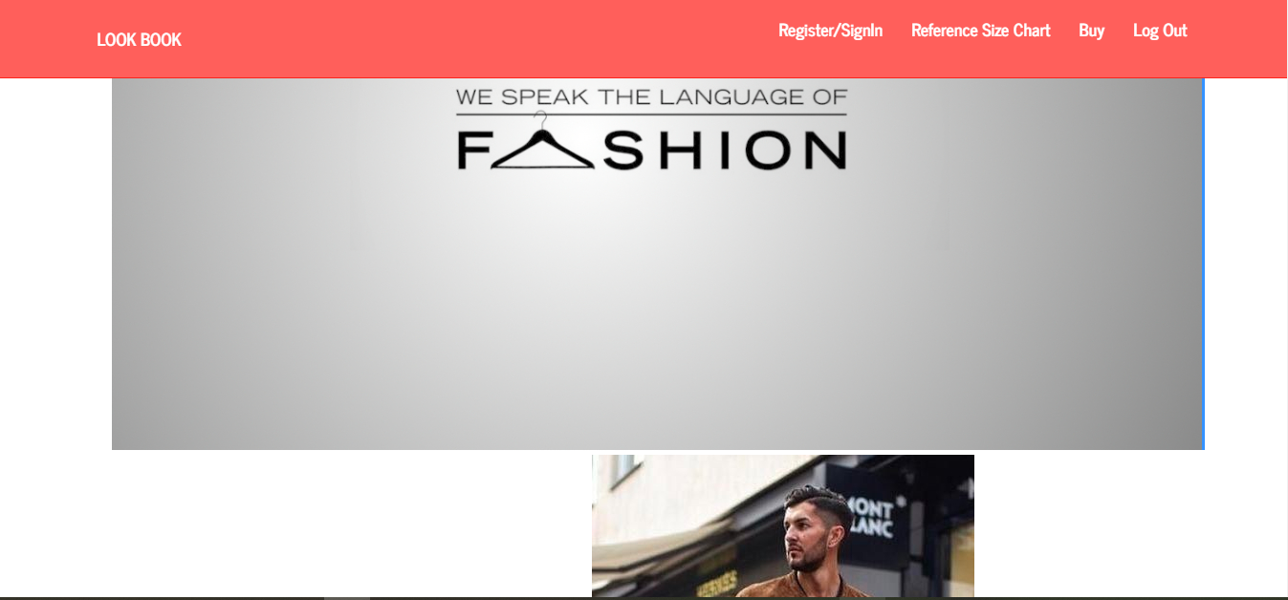

Figure 14: The Landing page.

**Register/Sign in page:**

For the new user, there is an option to create a new account. For the users who already have an account, they have an option to log in to the account. The credentials of the users are stored in the database and protected for security concerns. Under the register form, the mandatory details about the user needs to be filled.

**Log in page:**

Under the login option, username and password fields needs to be entered. If the user is an admin then the admin credentials should be used. The credentials are checked in the back end, if they exist in the database then the user/ admin will be able to log in. Once the admin can log in, he/she will be able to add products or any categories that are required. Only the admin will have access to the database where all the details, categories and the items will be stored. The change, update or delete functionalities can only be done by admin.

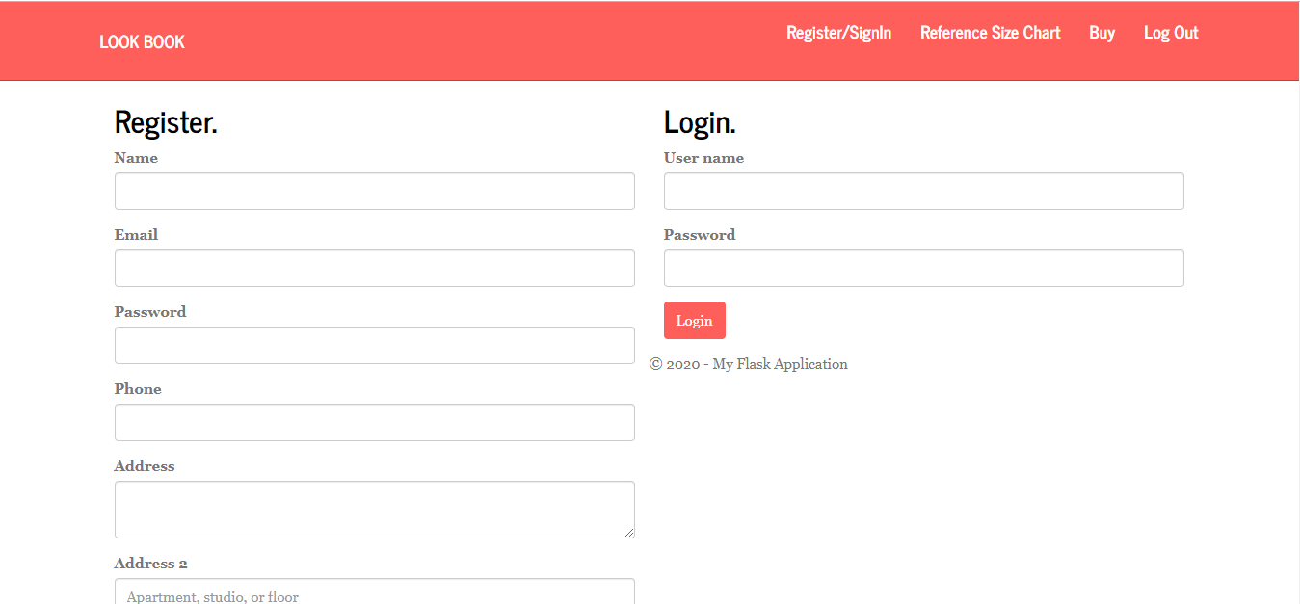

Figure 15: Register/Sign and Login page.

**Reference Size chart:**

The size chart is a static page where the measurements of the different sizes are mentioned. These details are for the just for information of the user. The users who are unaware of their body measurements can go through this chart and select the size required.

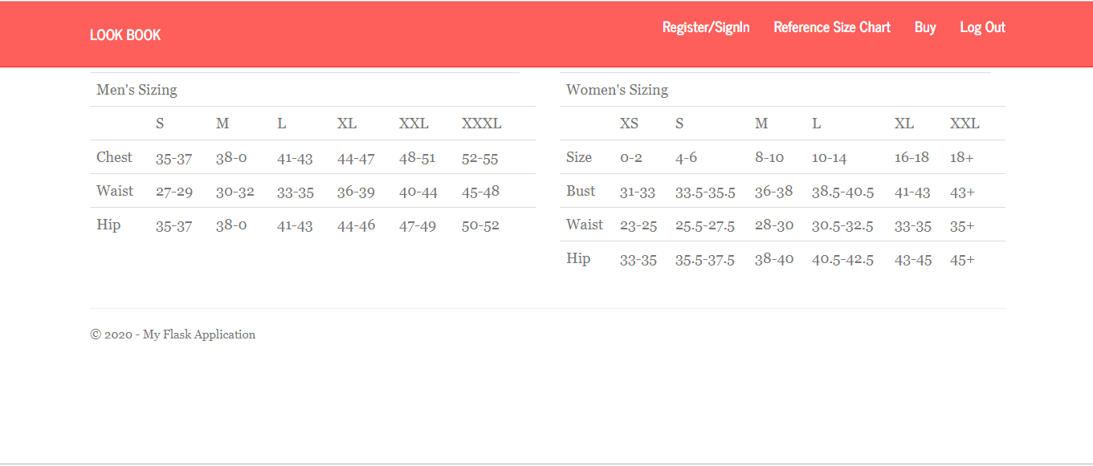

Figure 16: Reference size chart page.

## **4.2 Fashion outfit generation:**

Method for fashion outfit generation depends on the technique we have used to predict the outfit in this artefact. A priority matrix is implemented for the learning. This is a huge matrix column, where every column is associated with the input parameters selected by the users. And every row is associated with one unique identifier of each item. Based on the first few purchases, the priority matrix will be updated. We have filter co-efficient associated with every item. If the user searches for an outfit with same input parameters which has been purchased before, then the outfit with the highest priority under that search will be displayed first to the user followed by other outfits. If even 1 input parameter differs, then this will get added to the matrix and the learning will be done. As the purchase goes on, the priority matrix will keep updating.

The items purchased by the user are inserted in the table **cart_main** and the primary key is cart_id.

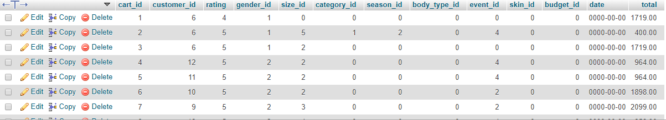

Figure 17: cart_main table.

The cart_main table does not contain the outfit which was purchased by the user. Because one user can have just one cart_id but one cart_id can have many numbers of items. Since one user can purchase any number of items the cart_id cannot be repeated in this table as it is the primary key. So, we create another table to include the cart_id called **cart_items**

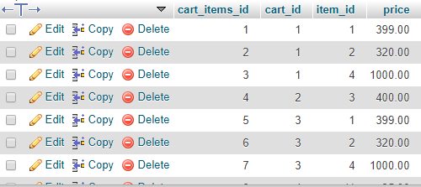

Figure 18: cart_items table.

In this table, the cart_id can be repeated based on the repetitive purchases done by the user. And the item_id and price too are inserted to know which outfit was purchased by the user, the primary key of this table is cart_items_id.

After the complete purchase, to store the data and add or increase the priority matrix we use the table learning_items. The tag management is used here, every category is assigned a tag type. Once the input parameters for the purchase are recorded, the system will search for the tags. If the tag_id matches with the same item_id it will update the table and increment the priority matrix by 1. If tag_id does not match with item_id, in this case the input parameters might be different then the data will be inserted in the table and the priority will be changed to 1.

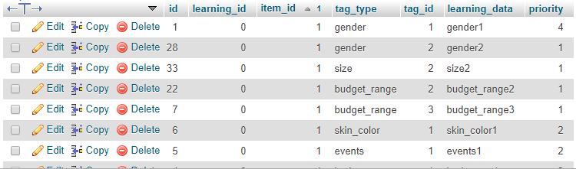

Figure 19: learning_items table.

The last step is to predict and sort the priority matrix, for this we are using the join function. We use inner join on category table and left join on learning_items table and sort the priority in descending order.

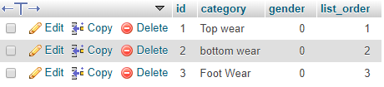

Figure 20: category table.

# 

**Chapter 5 : Testing and Evaluation**

## **5.1 Testing:**

Testing is the last phase of developing a software or an artefact. This phase shows that the program has met all its requirements and shows any presence of program defects before it is put into use. There are two ways to test the program, first we demonstrate to the user and the developer that the program is working fine and is meeting all the specified requirements. Tests should be conducted for all the features of the system and modules which will be included in the final delivery. Second, we input wrong parameters and create an unwanted situation where the software behaviour is incorrect. There could be many situations such as, defects in the software, system crash, data corruption and incorrect inputs. Every software must go through three stages of testing.

1)Development testing: During the development the system is tested to identify the defects int he program.

2)Release testing: In this testing, a complete version of the system will be tested. A different testing team will carry the process before releasing it to the users.

3)User testing: The system here is being tested by the users in their own environment. Under this, there is an acceptance testing where the end user tests if all the requirements are met or if any further development is needed.

## **5.2 Test cases:**

**Test case 1: Login functionality**

We have tested the login functionality for the positive input and the result is pass.

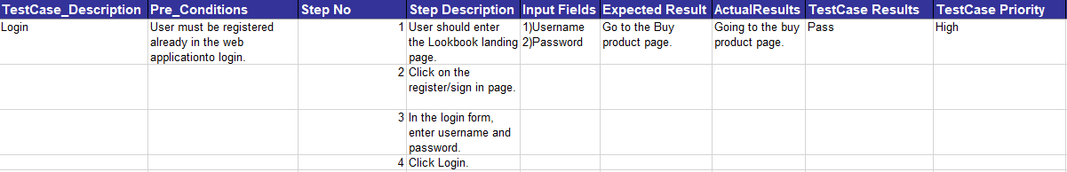

Figure 21: Positive login result.

**Test case 2: Login functionality**

We have tested the login functionality for the negative input and the result is fail.

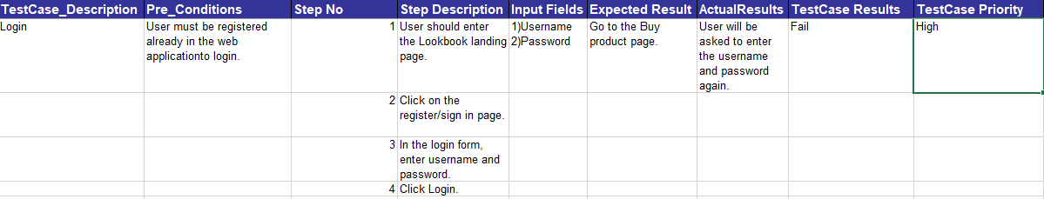

Figure 22: Negative login result.

**Test case 3: Buy functionality**

We have tested the buy functionality for the input parameters entered, and the outfit is being predicted and displayed.

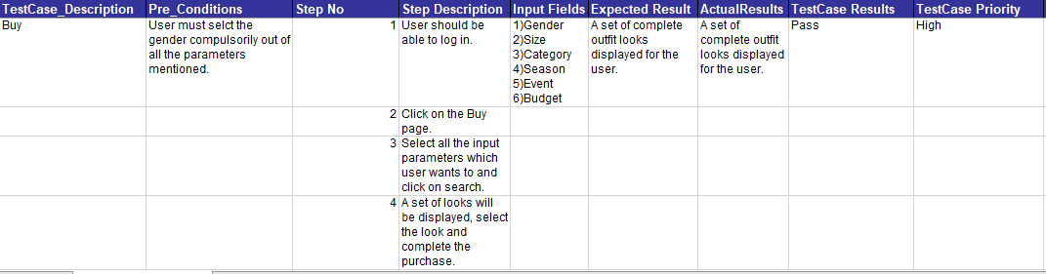

Figure 23: Positive buy prediction.

**Test case 3: Buy functionality**

We have tested the buy functionality for the input parameters entered incorrectly, and the outfit is being predicted wrong and the looks displayed are from random data.

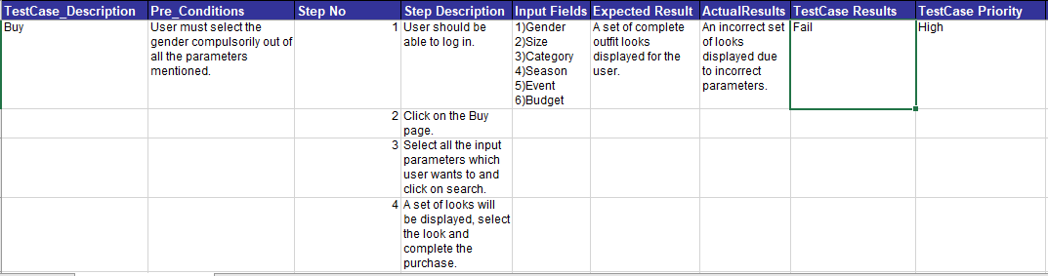

Figure 24: Negative buy prediction.

## **5.1 Artefact testing:**

Under this section, we are testing the hypotheses, different scenarios are considered where the research is tested for prediction. We will display a set of outfits based on inputs and user purchases.

### **5.1.1 Scenario 1:**

The first-time user logs in to purchase an outfit, he/she will input the parameters for the categories. As shown in the below screenshot, user has selected Female, Size M and event category as party. Then the below result will be shown to the user.

Figure 25: First time when user inputs the categories and clicks on search.

Once the search button is clicked, the set of outfits will be displayed to the user. Looks shown to the user are based on tag management because this is the first purchase. The order of the outfits is shown below.

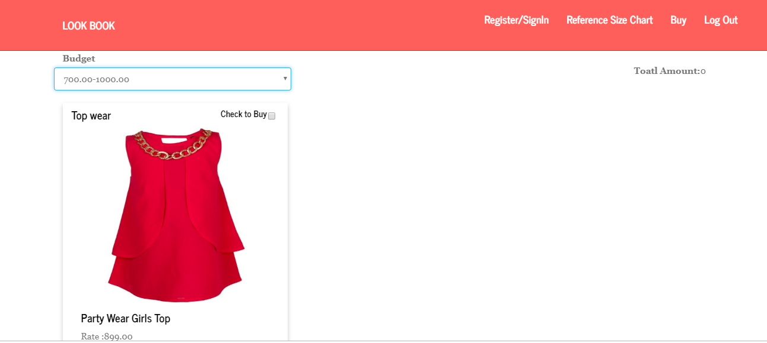

Figure 26: The order of outfits based on tag management as this is the first purchase.

Figure 27: The same as explained for Figure above.

Figure 28: The same as explained for Figure 26.

### **5.1.2 Scenario 2:**

After adding more products to the list. If 2 users logs in to the website, if they select the same inputs as the previous user then the list of outfits displayed will be more. If the outfit purchased by both the users are same. Then in the database under these categories, the outfit purchased in the first scenario is 1. And the outfits purchased by the 2nd and 3rd user is on priority 2.The screenshot below shows the new outfits purchased by the 2nd and 3rd user.

Figure 29: The outfit purchased by the 2nd and 3rd user.

### 

### **5.1.3 Scenario 3:**

Now when a user logs in and selects the party outfits then, the outfit whose priority in the database is 2 will be listed first.

Figure 30: The list of outfits shown to the last user.

Figure 31: The list of outfits shown to the last user.

## 

## **5.2 Data evaluation:**

At the end, after the purchase is done by the customer and the outfit has been selected. He/she will be asked to provide a 5-star customer feedback rating. This rating will be based on the whole shopping experience and the outfit recommendation system results . The rating data is being stored in the database. This data is collected to provide a proof to the artefact that fashion recommended systems are useful or not.

We are representing the data in the form of graph, where the X-axis is the customer rating and the Y-axis is divided into 3 options which are Negative, Neutral and Positive. As the number of customer ratings increases the X-axis will fluctuate in the graph. The ranging for Negative is 1 and 2, ranging of neutral rating is 3 and ranging of positive rating is 4 and 5.

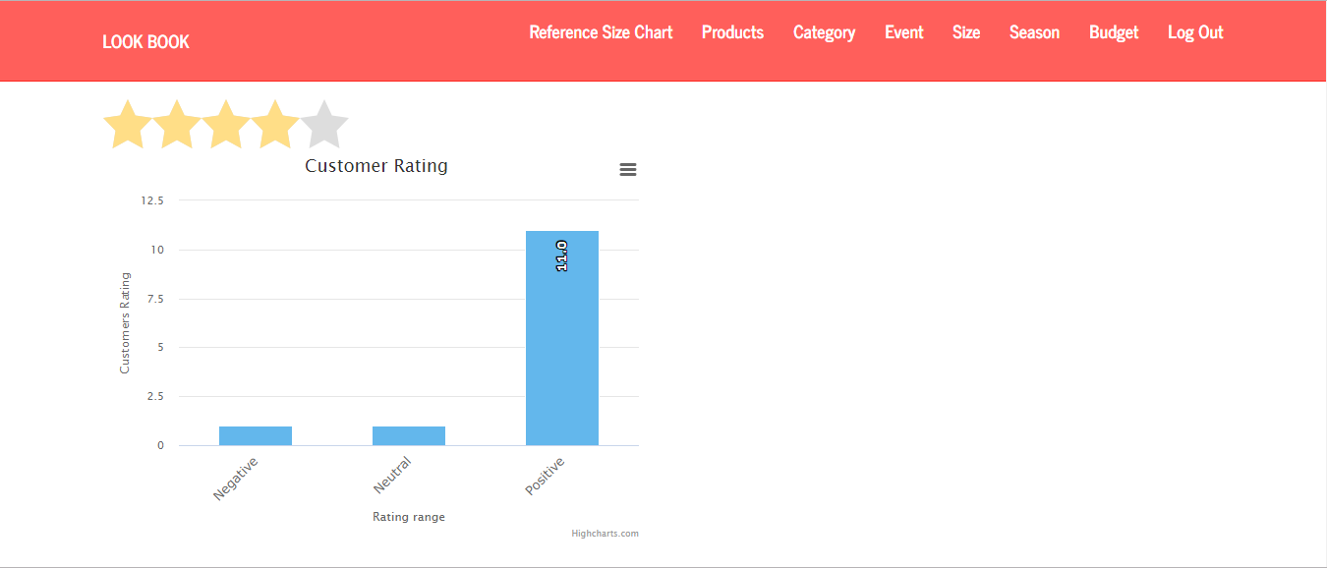

Figure 32: Graph representing the customer feedback rating.

# 

**Chapter 6 : Discussions**

In this chapter, we will scrutinize the results and feedback we received in the study evaluation. Evaluation of research question and the possible explanation is discussed here. We will also discuss the limitation of this research including the artefact and thesis.

## **6.1 General perspectives:**

The user experience was collected to know about the user experience of the recommendation system. We collected few ratings about the shopping experience from the end users. The responses received at the end after the purchase are majorly positive. There are very less responses for negative, which means that people prefer this recommendation system. The results after testing the data are reviewed as, the shopping experience is easy and feasible. The preference of a recommendation system based on inputs is high. Majority of E-commerce platforms do not have this ease of shopping experience.

## **6.1 Reviewing the research question:**

**Research Question : Can machine Learning be used to effectively address the idea of creating a fashion trend?**

Considering the latest trend in the fashion field a detailed literature review was done to develop the best artefact. The fashion sector was selected to deploy in this model because of the increasing demand of fashion recommendation systems in the fashion industry. Instead of going to a shop physically and buying a product. Users prefer to shop online, but not every website will have a fashion counsellor who might suggest user the best outfits or a fashion recommendation system. The trends with fashion change every day and the outfits change depending on the trend running in the market. Keeping this in mind the research question was created. In recent times, the recommendation systems are being implemented in the web application or these features are used as a plugin to a web application. All the research was done on the fashion industry, Lookbook and the recommendation systems. The users shopping experience will become easy and self-explanatory if we include a recommendation system. If the users go through the system and select the inputs required depending on the user’s requirements then a set of fashion outfits will be generated. After reading and understanding many other existing works with different technologies of Artificial Intelligence, Machine learning. It was clear that this module should be deployed within the fashion industry. Machine learning was selected as a technique for the system to learn. Python flask libraries are incorporated in this module to develop the artefact. The artefact design was done after going through various papers on such systems. In this research work, we are creating a web application where the users can input the parameters and based on the purchase patterns of the user the learning is done and the outfits are generated. As discussed in earlier sections, we have used priority matrix and the learning keeps increasing as the purchases increase. Using machine learning can simplify the procedure and could be easy to retrieve results based on the learning. The project needed to be designed keeping the end user in the mind. Thus, the portal is simple and understandable to the end user. We met users personally and asked them to use the portal, try accessing the web application and the recommendation system and then give a customer feedback star rating after the purchase. The feedback section is embedded in the module at the end which will get saved in the database. The results of the feedback revelated that most of the users prefer this recommendation system.

## **6.2 Limitations:**

This research has certain amount of limitations to the system. Due to complexity constraints, we could not create a plugin which could be embedded in any web application. We are implementing this recommendation system on the web application platform, however only the products related to this research are added. The whole market is not taken into consideration. Due to time constraints, we have not included the payment page. And we are assuming that when a user selects the products to purchase, they will purchase the product.

**Chapter 7 : Conclusion and Future Work**

The main objective of this thesis was to create a fashion recommendation system, which will help users to select complete outfits based on self-profiling. Also, to make the shopping experience easy for the end user. The Lookbook was created with Machine Learning techniques, which have been implemented on different platforms with different techniques in the past. As discussed in the literature review, building a system which will suggest outfits automatically using priority matrix is the best way to develop the artefact. Star feedback rating in the web application is collected as the feedback from the customers after the completion of purchase. The feedback helped our research give evidence to prove that the research we are conducting and the research question we stated in this thesis. The overall experience of online shopping for fashion products has been taken to a new level. This dissertation provides a new fashion recommendation system to be deployed in the E-commerce platforms. In this artefact, there is potential to develop an advanced version of this system for future work. A plugin can be created and can be used in any major platform. As revealed by the feedback results, most of the users do prefer such recommendation systems. The users found the complete interface easy and handy. In future, the recommendation systems can be developed with other techniques too. As fashion ever gets old it keeps changing every day and there is scope for new functionalities. Thus, we can conclude that such systems are self-explanatory and can be used by anyone without prior training. The combination of Artificial Intelligence and fashion recommendation systems have taken over the world.

# **Appendix A:**

## **A.1 Code Snippet.**

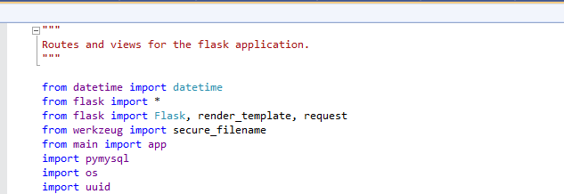

Figure 33: Libraries used in the program.

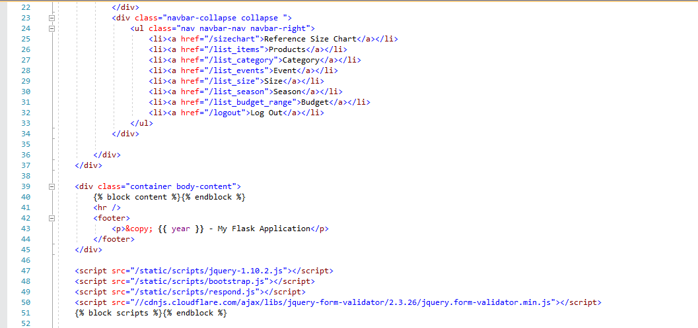

Figure 34: Admin module creation.

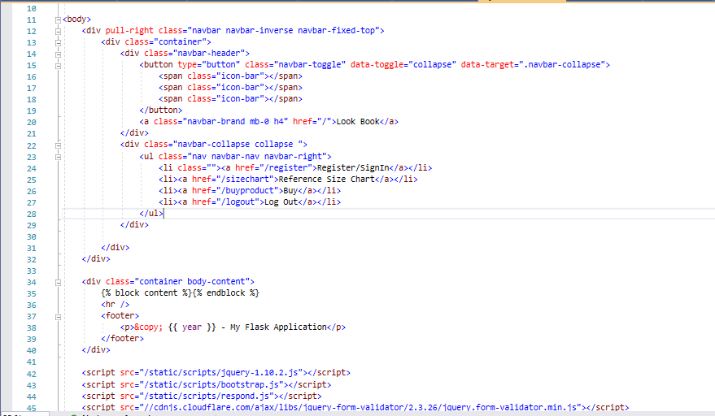

Figure 35: Landing page creation.

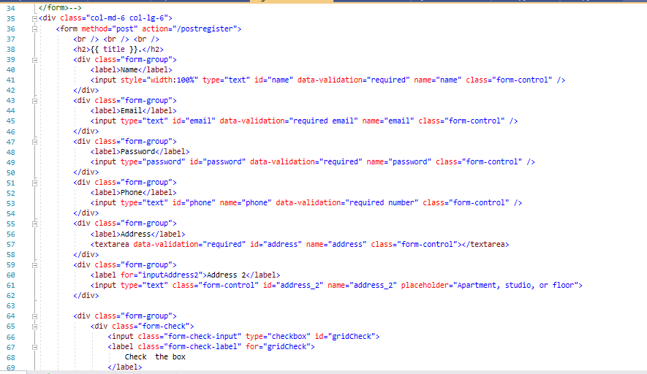

Figure 36: Register module function.

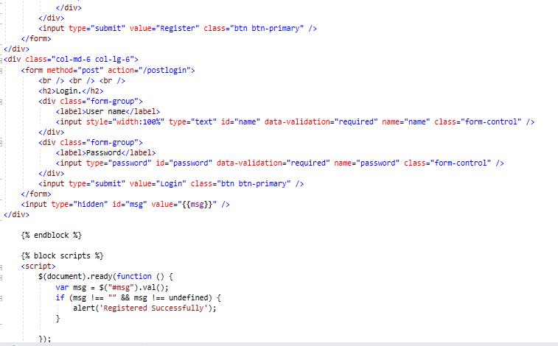

Figure 37: Login module function.

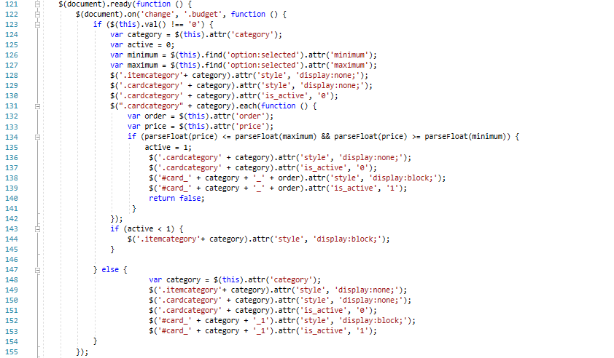

Figure 38: Buy product page creation.

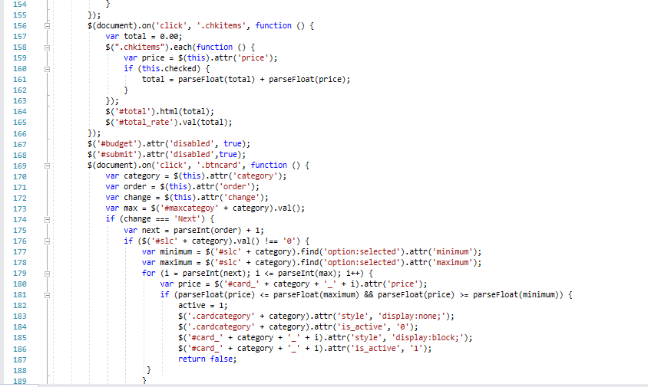

Figure 39: Buy product page creation.

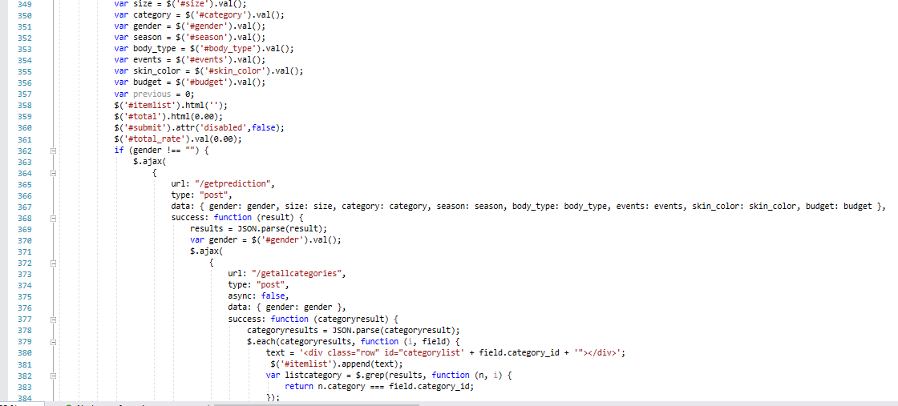

Figure 40: Buy Product functionality.

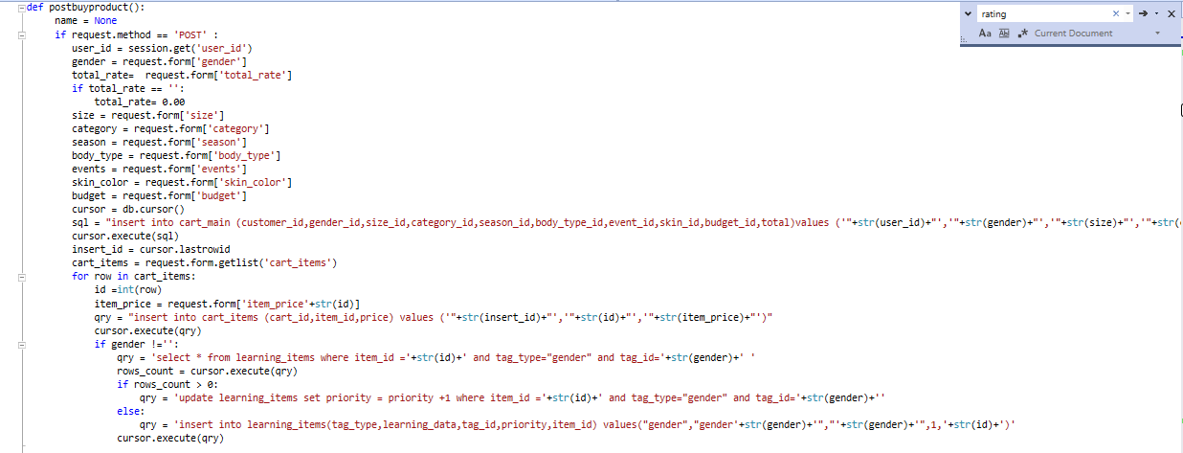

Figure 41: Post Buy Product functionality.

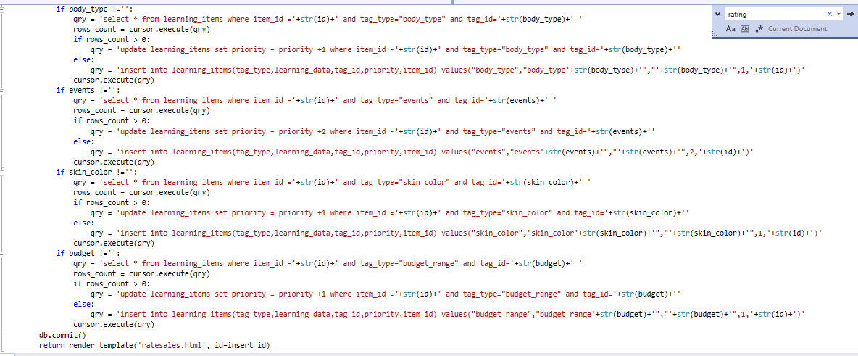

Figure 42: Post Buy Product functionality.

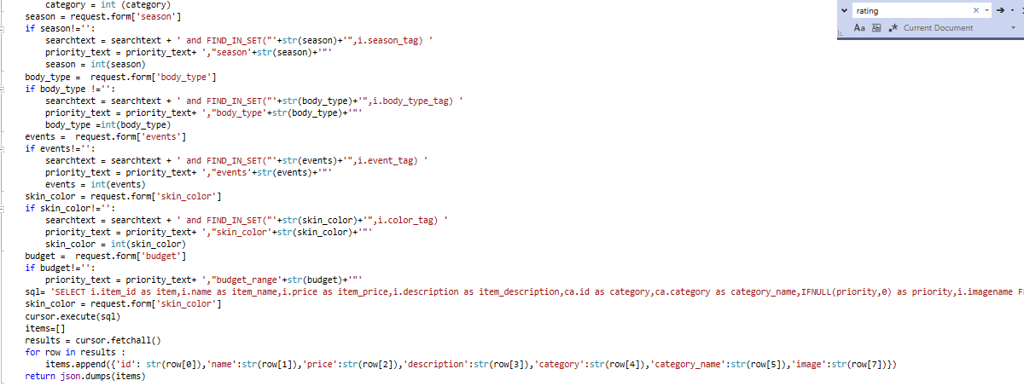

Figure 43: Prediction functionality.

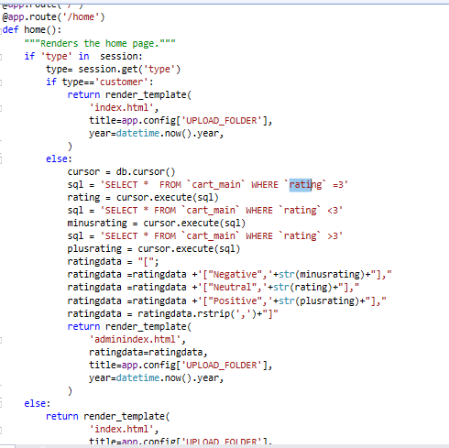

Figure 44: Feedback rating functionality.

**References:**

1 *4. Ranking: Priority Inbox - Machine Learning for Hackers [Book]* (no date). Available at: https://www.oreilly.com/library/view/machine-learning-for/9781449330514/ch04.html (Accessed: 6 January 2020).

Bhuran, S., Mundhe, S. and Bhave, M. D. (no date) ‘Face Recognition and Image Processing in E-Commerce Domain’, 05(04), p. 2.

Chanana, N. and Goele, S. (2012) ‘FUTURE OF E-COMMERCE IN INDIA’, in.

Chavaltada, C., Pasupa, K. and Hardoon, D. R. (2017) ‘A Comparative Study of Machine Learning Techniques for Automatic Product Categorisation’, in Cong, F., Leung, A., and Wei, Q. (eds) *Advances in Neural Networks - ISNN 2017*. Cham: Springer International Publishing, pp. 10–17. doi: 10.1007/978-3-319-59072-1_2.

Chen, W. *et al.* (2019) ‘POG: Personalized Outfit Generation for Fashion Recommendation at Alibaba iFashion’, *arXiv:1905.01866 [cs]*. Available at: http://arxiv.org/abs/1905.01866 (Accessed: 29 December 2019).

Cote, D. (2018) ‘Using machine learning in communication networks [Invited]’, *IEEE/OSA Journal of Optical Communications and Networking*, 10(10), pp. D100–D109. doi: 10.1364/JOCN.10.00D100.

DeMatas, D. (2019) *5 Types of Ecommerce Business Models That Work Right Now*, *https://www.ecommerceceo.com/*. Available at: https://www.ecommerceceo.com/types-of-ecommerce-business-models/ (Accessed: 26 December 2019).

Giri, C. *et al.* (2019) ‘A Detailed Review of Artificial Intelligence Applied in the Fashion and Apparel Industry’, *IEEE Access*, 7, pp. 95376–95396. doi: 10.1109/ACCESS.2019.2928979.

*Global Ecommerce 2019* (no date) *eMarketer*. Available at: https://www.emarketer.com/content/global-ecommerce-2019 (Accessed: 13 January 2020).

Gray, C. *et al.* (2015) ‘Personalized online search for fashion products’, in *2015 Systems and Information Engineering Design Symposium*. *2015 Systems and Information Engineering Design Symposium*, pp. 91–96. doi: 10.1109/SIEDS.2015.7117018.

Holden, M. T. and Lynch, P. (2004) ‘Choosing the Appropriate Methodology: Understanding Research Philosophy’, *The Marketing Review*, 4(4), pp. 397–409. doi: 10.1362/1469347042772428.

Hsiao, W.-L. and Grauman, K. (2018) ‘Creating Capsule Wardrobes from Fashion Images’, in *2018 IEEE/CVF Conference on Computer Vision and Pattern Recognition*. *2018 IEEE/CVF Conference on Computer Vision and Pattern Recognition (CVPR)*, Salt Lake City, UT: IEEE, pp. 7161–7170. doi: 10.1109/CVPR.2018.00748.

Jain, H. (2015) ‘The concepts of e-commerce & e-marketplace has revolutionized’, February. Available at: http://www.fibre2fashion.com/industry-article/7511/role-of-e-commerce-in-apparel-fashion (Accessed: 25 December 2019).

Kalantidis, Y., Kennedy, L. and Li, L.-J. (2013) ‘Getting the look: clothing recognition and segmentation for automatic product suggestions in everyday photos’, in *Proceedings of the 3rd ACM conference on International conference on multimedia retrieval - ICMR ’13*. *the 3rd ACM conference*, Dallas, Texas, USA: ACM Press, p. 105. doi: 10.1145/2461466.2461485.

Kalinina, N. V. (2017) ‘Fashion as factor of social adaptation of youth’, *История российской психологии в лицах: Дайджест - ISSN 2415-7953 (РИНЦ)*, 0(0), pp. 89–92.

Khandelwal, R. (no date) ‘Graduation Research Project Expansion of Product line in Grey Fashion Company’, p. 92.

Liu, S. *et al.* (no date) ‘Hi, magic closet, tell me what to wear!’, p. 10.

Lo, L. *et al.* (2019) ‘Dressing for Attention: Outfit Based Fashion Popularity Prediction’, in *2019 IEEE International Conference on Image Processing (ICIP)*. *2019 IEEE International Conference on Image Processing (ICIP)*, pp. 3222–3226. doi: 10.1109/ICIP.2019.8803461.

Maamar, Z. (2003) ‘(PDF) Commerce, e-commerce, and m-commerce: what comes next?’, *ResearchGate*. Available at: https://www.researchgate.net/publication/220426677_Commerce_e-commerce_and_m-commerce_what_comes_next (Accessed: 25 December 2019).

Ristoski, P. *et al.* (2018) ‘A machine learning approach for product matching and categorization: Use case: Enriching product ads with semantic structured data’, *Semantic Web*. Edited by C. d’Amato, 9(5), pp. 707–728. doi: 10.3233/SW-180300.

Saunders, M. N. K., Lewis, P. and Thornhill, A. (2009) *Research methods for business students*. 5th ed. New York: Prentice Hall.

‘Sense of style: Constructing Identity and managing impressions on Lookbook.NU’ (no date), p. 120.

Sommerville, I. (2016) *Software engineering*. Tenth edition, global edition. Boston Columbus Indianapolis New York San Francisco Hoboken Amsterdam Cape Town Dubai London Madrid Milan Munich Paris Montreal Toronto Delhi Mexico City São Paulo Sydney Hong Kong Seoul Singapore Taipei Tokyo: Pearson (Always learning).

Stefan, V. and Nicklas, L. (2017) *Product categorisation using machine learning*. Available at: http://urn.kb.se/resolve?urn=urn:nbn:se:kth:diva-209031 (Accessed: 30 December 2019).

‘Time horizon: cross-sectional versus longitudinal studies’ (2016) *Le Petite Chat*, 2 June. Available at: https://kalyaneynath.wordpress.com/2016/06/02/time-horizon-cross-sectional-versus-longitudinal-studies/ (Accessed: 1 January 2020).

Venkatasamy, N. (2015) *Fashion trends and their impact on the society*.

‘What is Machine Learning? Understanding Machine Learning and its Types’ (no date) *Analytics Vidhya*. Available at: https://www.analyticsvidhya.com/machine-learning/ (Accessed: 30 December 2019).

Zhan, H. *et al.* (2019) ‘Fashion Recommendation on Street Images’, in *2019 IEEE International Conference on Image Processing (ICIP)*. *2019 IEEE International Conference on Image Processing (ICIP)*, pp. 280–284. doi: 10.1109/ICIP.2019.8802939.